**BI REPORT**

**PURCHASING ORDER MODULE**

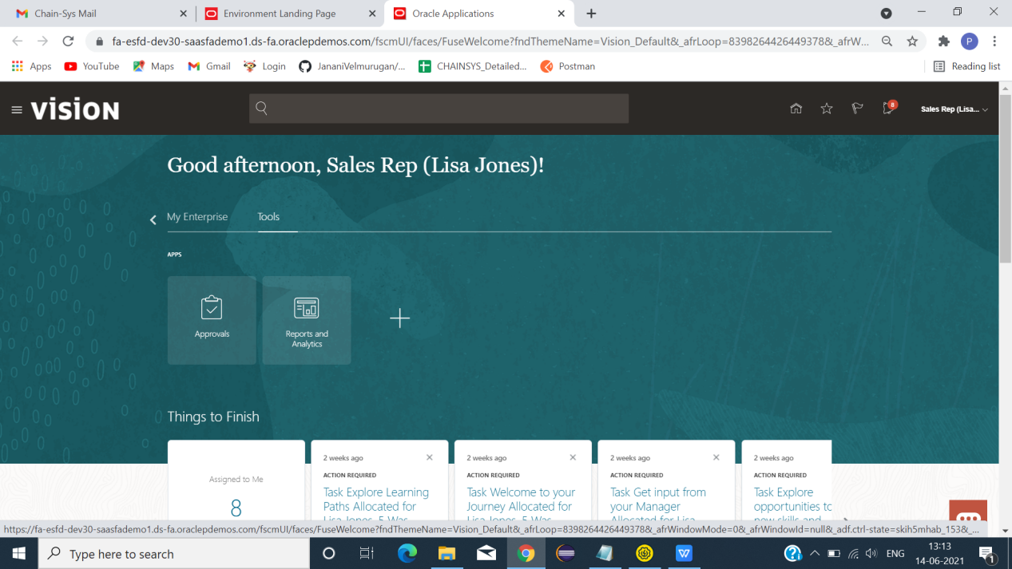

*CONNECT TO ORACLE SERVER AND CLICK TOOLS -> REPORT AND ANALYSIS.

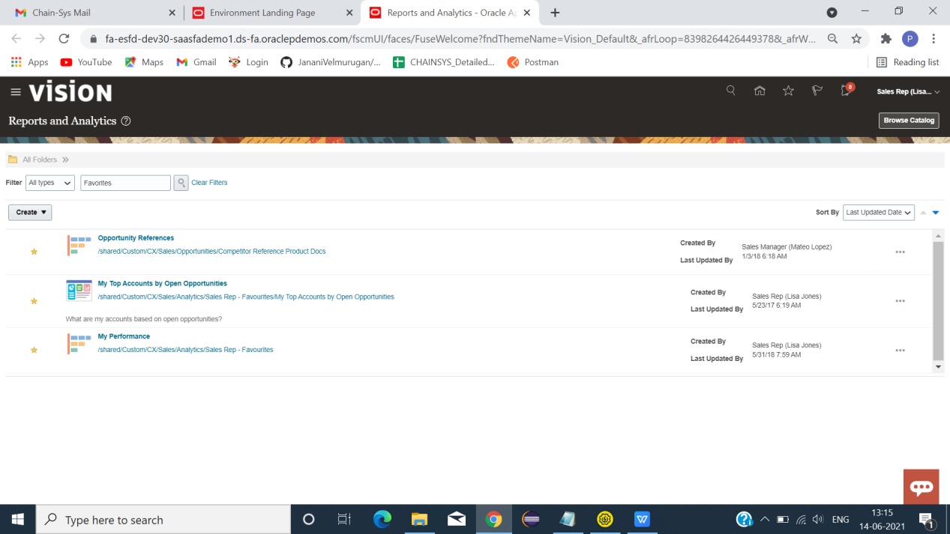

*CLICK BROWSE CATALOG.

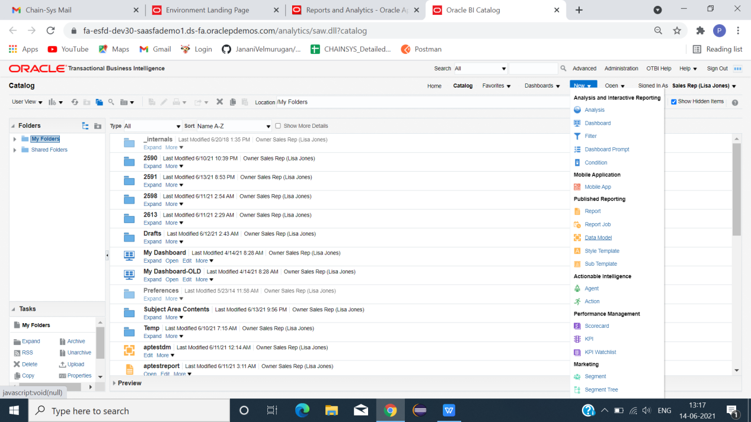

*CLICK NEW -> DATA MODEL.

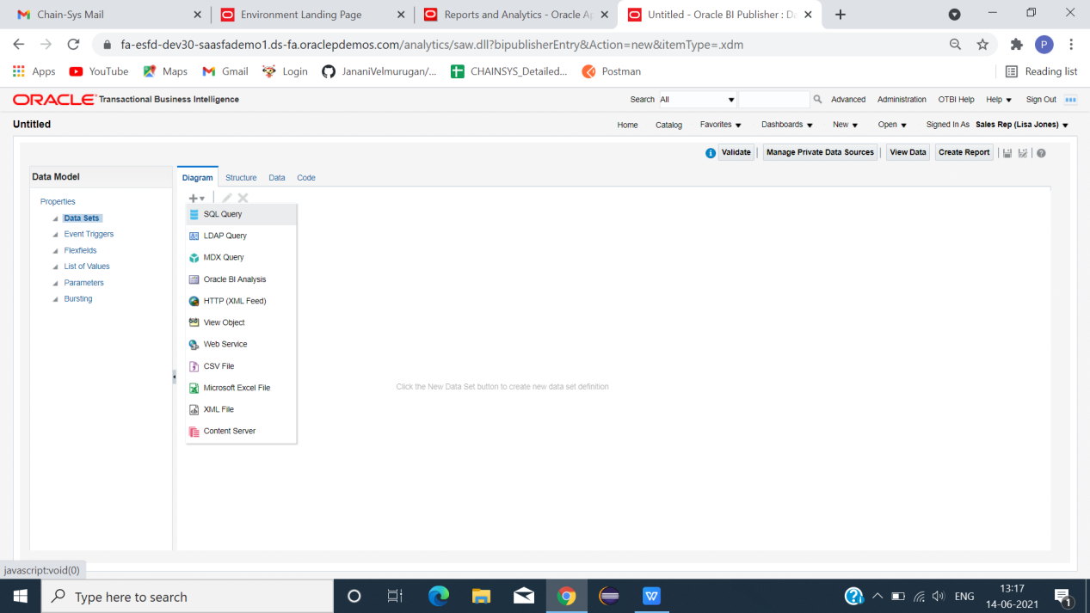

*CLICK + -> SQL QUERY.

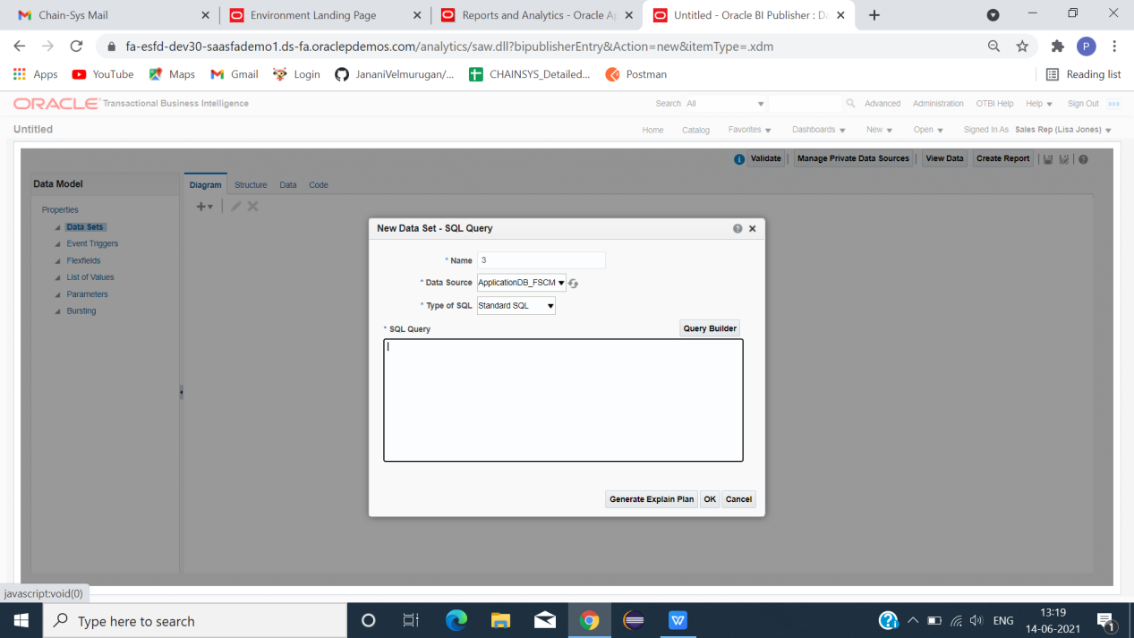

*GIVE NAME AND SELECT DATA SOURCE -> APPLICATIONDB_FSCM.

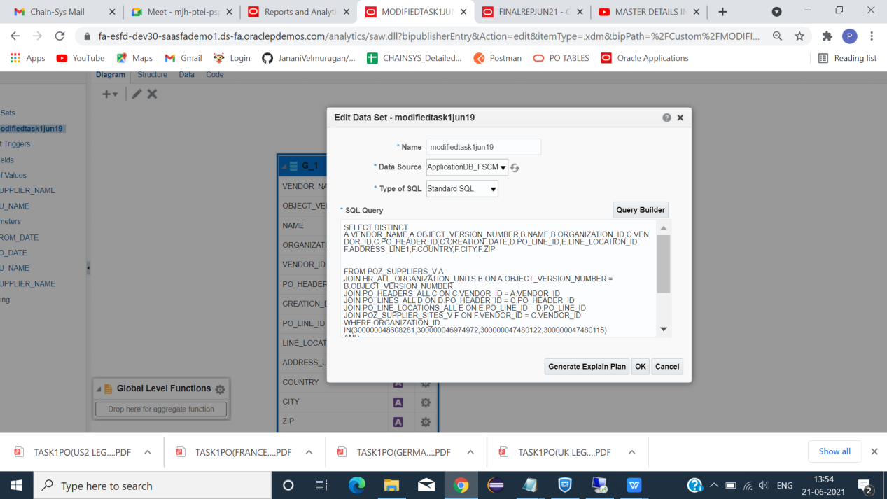

*SELECT TABLE NAME,COLUMN,LINK BETWEEN TABLES(COLUMN),FOREIGN KEYS(ALL DATA WE NEED TO CREATE REPORT).

**SQL QUERY FOR PO TABLES**

=================================================================================

SELECT DISTINCT A.VENDOR_NAME,A.OBJECT_VERSION_NUMBER,B.NAME,B.ORGANIZATION_ID,C.VENDOR_ID,C.PO_HEADER_ID,TO_CHAR(C.CREATION_DATE,'DD-MM-YYYY') AS CREATION_DATE,TO_CHAR(SYSDATE,'DD-MM-YYYY') AS REPORT_DATE,D.PO_LINE_ID,E.LINE_LOCATION_ID,

F.ADDRESS_LINE1,F.COUNTRY,F.CITY,F.ZIP,C.CURRENCY_CODE,C.COMMENTS,C.DOCUMENT_STATUS

FROM POZ_SUPPLIERS_V A

JOIN HR_ALL_ORGANIZATION_UNITS B ON A.OBJECT_VERSION_NUMBER = B.OBJECT_VERSION_NUMBER

JOIN PO_HEADERS_ALL C ON C.VENDOR_ID = A.VENDOR_ID

JOIN PO_LINES_ALL D ON D.PO_HEADER_ID = C.PO_HEADER_ID

JOIN PO_LINE_LOCATIONS_ALL E ON E.PO_LINE_ID = D.PO_LINE_ID

JOIN POZ_SUPPLIER_SITES_V F ON F.VENDOR_ID = C.VENDOR_ID

WHERE ORGANIZATION_ID IN(300000048608281,300000046974972,300000047480122,300000047480115)

AND

A.VENDOR_NAME = NVL(:SUPPLIER_NAME,A.VENDOR_NAME)

AND

B.NAME = NVL(:BU_NAME,B.NAME)

AND

C.CREATION_DATE >= NVL(:FROM_DATE,C.CREATION_DATE)

AND

C.CREATION_DATE <= NVL(:TO_DATE,C.CREATION_DATE)

AND

A.VENDOR_NAME IN('Edison Co', 'Progressive Corp', 'CLP', 'EDF', 'RSM', 'Siemens Medical Solutions', 'Howell Engineering Inc')

AND

D.PO_LINE_ID IN(62558.00,62577.00,63120.00,29093.00,300000095164124.00,300000079220543.00,31811.00,31820.00,38047.00,38048.00,168576.00,182215.00)

=================================================================================

**TABLE LINKS**

|  |  |  |
| --- | --- | --- |
| TABLE NAME 1 | LINKING COLUMN NAME | TABLE NAME 2 |
| POZ_SUPPLIERS_V  SELECTED COL:VENDOR_NAME | OBJECT_VERSION_NUMBER | HR_ALL_ORGANIZATION_UNITS  SELECTED COL:OBJECT_VERSION_NUMBER,ORGANIZATION_ID |
| PO_HEADERS_ALL  SELECTED COL:VENDOR_ID,PO_HEADERS_ID,PO_CREATION_DATE | PO_HEADER_ID | PO_LINES_ALL  SELECTED COL:PO_LINE_ID |
| PO_LINE_LOCATIONS_ALL  SELECTED COL:LINE_LOCATION_ID | PO_LINE_ID | PO_LINES_ALL  SELECTED COL:PO_LINE_ID |
| POZ_SUPPLIER_SITES_V  SELECTED COL:ADDRESS_LINE1,COUNTRY,CITY,ZIP | VENDOR_ID | PO_HEADERS_ALL  SELECTED COL:VENDOR_ID,PO_HEADERS_ID,PO_CREATION_DATE |

===================================================================================

**PRAMETER DETAILS**

|  |  |  |
| --- | --- | --- |
| COLUMN NAME | PARAMETER TYPE | PARAMETER NAME |
| VENDOR_NAME | NORMAL PARAMETER | SUPPLIER_NAME |
| NAME | NORMAL PARAMETER | BU_NAME |
| CREATION_DATE(FROM) | NORMAL PARAMETER | FROM_DATE |
| CREATION_DATE(TO) | NORMAL PARAMETER | TO_DATE |
| SUPPLIER_NAME | DEPENDENCY PARAMETER WITH | BU_NAME |

===================================================================================

**PARAMETER**

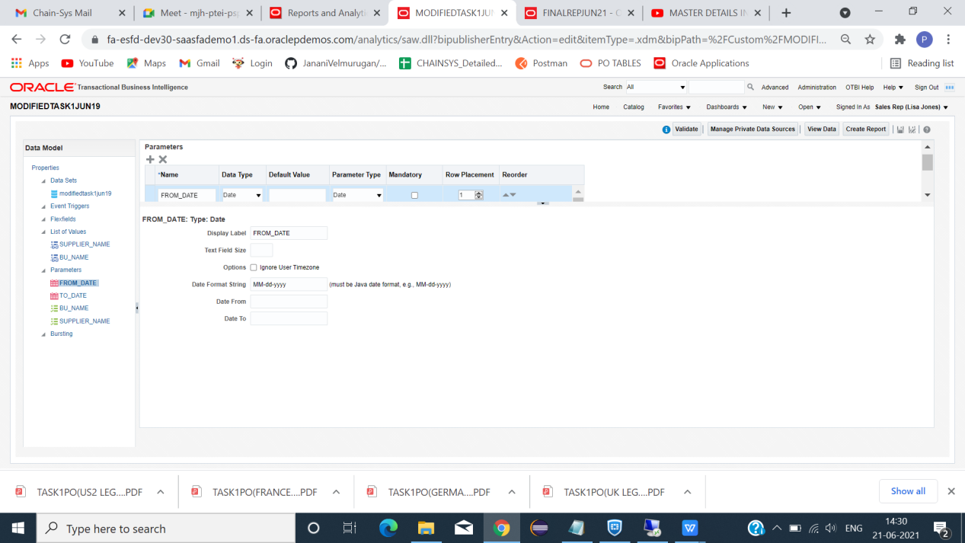

*PARAMETER -> +ICON ->NAME->PARAMETER TYPE(DATE)->DISPLAY LABEL ->(NAME).[FROM_DATE]

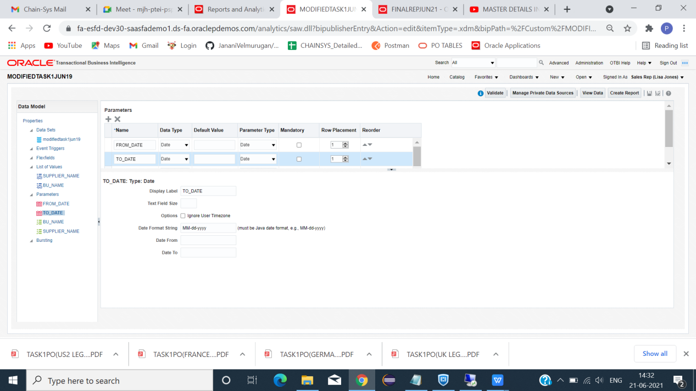

*PARAMETER -> +ICON ->NAME->PARAMETER TYPE(DATE)->DISPLAY LABEL ->(NAME).[TO_DATE]

(NOTES: FOR DATE NO NEED TO CREATE LIST OF VALUES).

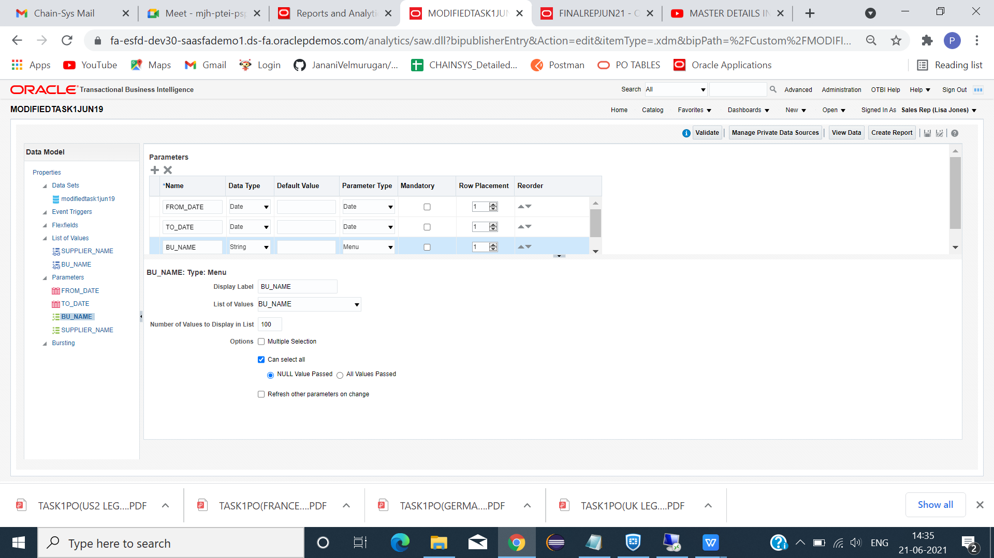

*PARAMETER -> +ICON ->NAME->PARAMETER TYPE(MENU)->DISPLAY LABEL ->(NAME).[BU_NAME]

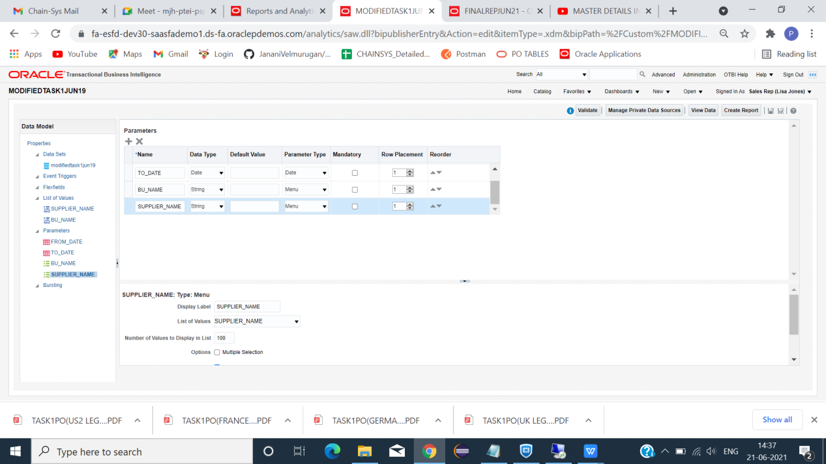

*PARAMETER -> +ICON ->NAME->PARAMETER TYPE(MENU)->DISPLAY LABEL ->(NAME).[SUPPLIER_NAME].

**LIST OF VALUES**

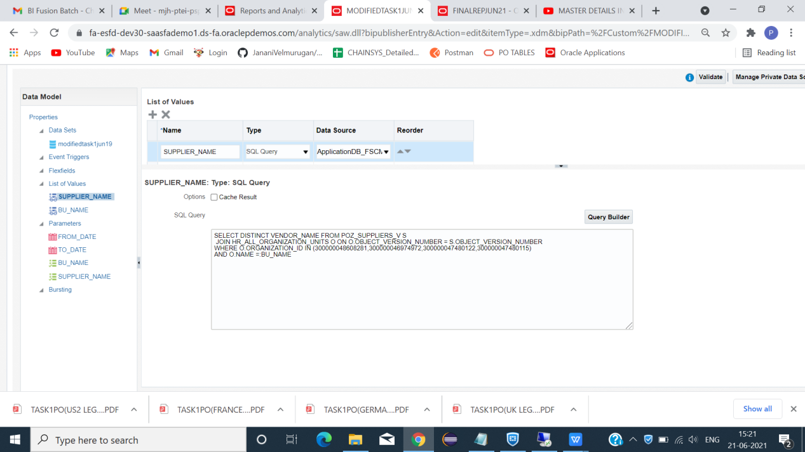

*CLICK +ICON TO ADD LIST OF VALUES.

**SQL QUERY FOR SUPPLIER_NAME DEPENDENCY WITH BU_NAME**

=======================================================

SELECT DISTINCT VENDOR_NAME FROM POZ_SUPPLIERS_V S

JOIN HR_ALL_ORGANIZATION_UNITS O ON O.OBJECT_VERSION_NUMBER = S.OBJECT_VERSION_NUMBER

WHERE O.ORGANIZATION_ID IN (300000048608281,300000047480122,300000047480115)

AND

S.VENDOR_NAME IN('Edison Co', 'Progressive Corp', 'CLP', 'EDF', 'RSM', 'Siemens Medical Solutions')

AND O.NAME =:BU_NAME

=====================================================================

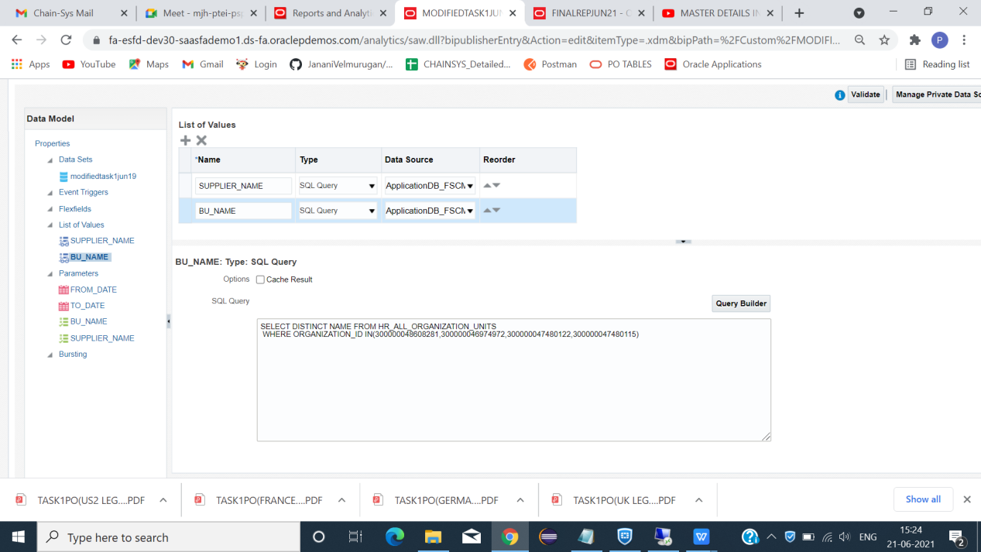

*CLICK +ICON TO ADD LIST OF VALUES.

**SQL QUERY FOR BU_NAME**

====================================================================

SELECT DISTINCT NAME FROM HR_ALL_ORGANIZATION_UNITS

WHERE ORGANIZATION_ID IN(300000048608281,300000047480122,300000047480115)

=====================================================================

*SAVE THE DATA MODEL.

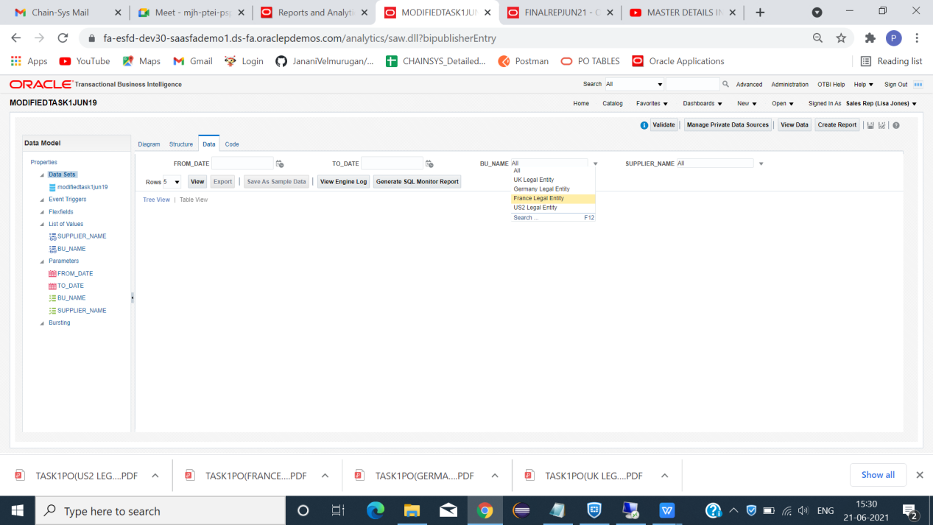

*CLICK DATA -> BU_NAME(SELECT ONE)->SUPPLIER_NAME(SUPPLIER CORRESPONDING TO BU NAME).

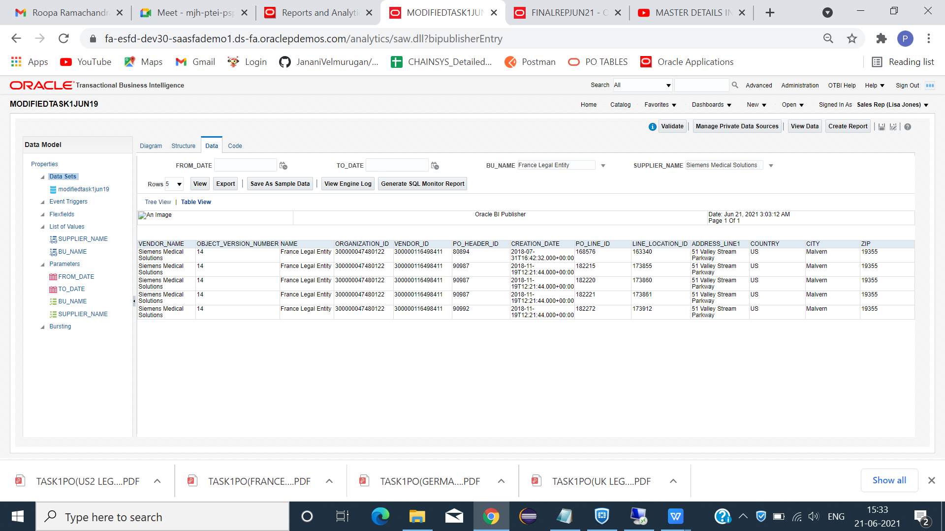

*CLICK -> SAVE AS SAMPLE DATA -> EXPORT(SAMPLE XML).SAVE.

**GO WORD BI PUBLISHER**

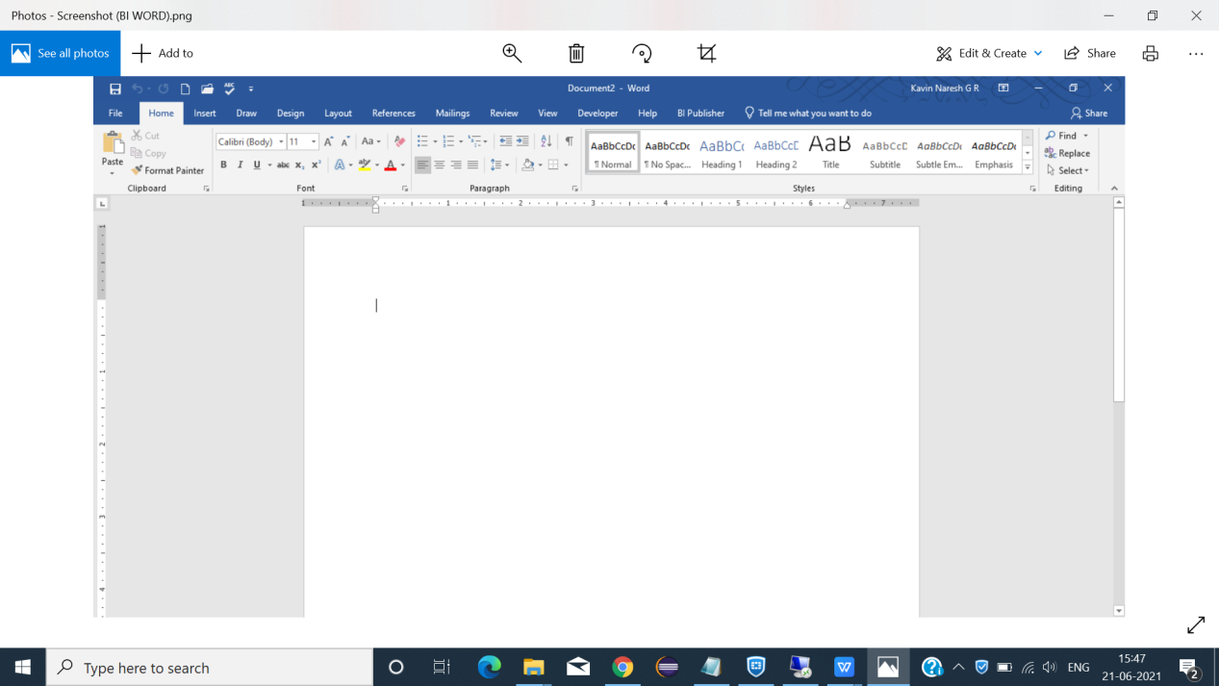

**CREATING MULTIPLE LAYOUT**

**scenario 1 steps(NOT RECOMMENDED)**

STEP 1:GO TO BI PUBLISHER -> SAMPLE DATA -> SELECT(XML FILE).

STEP 2:HEADER -> INSERT -> PICTURE(LOGO) AND IN FOOTER INSERT PAGE NUMBER.

STEP 3:INSERT THE FIELDS(AS WE NEED IN TOP OF PAGE(SUPPLIER DETAILS,BU NAME)).

**GROUP BY BU NAME(MULTIPLE LAYOUT)**

STEP 4:CLICK TABLE WIZARD ->NEXT->NEXT->SELECT COLUMN(INCLUDE GROUPING COLUMN)->NEXT->GROUP BY(NAME)->NEXT.(TABLE CREATED FOR SPECIFIED COLUMN(CORRESPONDING TO GROUP COLUMN)).

STEP 5:CLICK -> DEVELOPER TAB->DOUBLE CLICK NAME(BU NAME)->CODE BOX OPEN-> <?if:NAME=’GIVE BU NAME’?>EXAMPLE->[<?if:NAME=’France Legal Entity’?>].

Step 6: PLACE CURSOR BEFORE END BY NAME(BU NAME) -> LEGACY FORMS ->CLICK-> ab| ->CODE TABLE APPEAR -> END THE IF -> <?end if?> -> OK.

STEP 7: SIMILARLY,CREATE MULTIPLE SECTION CORRESPONDING TO BU NAME.

STEP 8:SAVE FILE AS RTF FORMAT.

**EXACT CORRECT SCENARIO**

STEP 1:GO TO BI PUBLISHER -> SAMPLE DATA -> SELECT(XML FILE).

STEP 2:HEADER -> INSERT -> PICTURE(LOGO) AND IN FOOTER INSERT PAGE NUMBER.

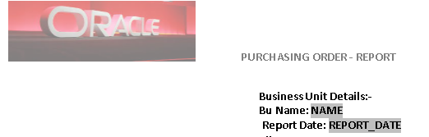

STEP 3:INSERT THE FIELDS(AS WE NEED IN TOP OF PAGE(BU NAME)).

**GROUP BY BU NAME(MULTIPLE LAYOUT)**

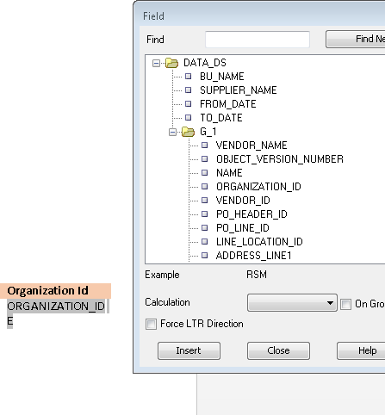

LOAD SAMPLE DATA ->FIELDS ->SELECT COLUMNS AS U NEED INSIDE TABLE(LIKE THIS)

Step4:INORDER TO SEPERATE COLUMNS ACCORDING TO BU NAME USE IF CONDITION.

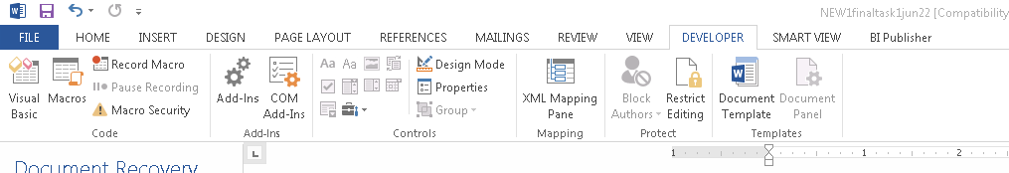

STEP5:GO TO DEVELOPER->CONTROLS->LEGACY TOOLS->CLICK -> ab| -> CODE.

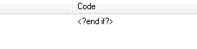

STEP6:<?if:NAME='UK Legal Entity'?> (OPENING OF IF STATEMENT)<?end if?>(CLOSING IF STATEMENT)

STEP7:TO DISPLAY VENDOR DETAILS SEPERATELY FOR ALL COLUMNS(SEPERATED BY BU) USE FOR EACH CONDITION.



STEP8:<?for-each-group:G_1;./VENDOR_NAME?>(OPENING FOR EACH CONDITION)<?end for-each-group?>(CLOSING FOR EACH CONDITION)

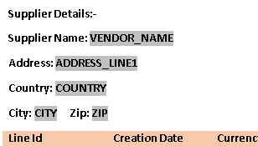

STEP9:LEGACY TOOL->CODE-><?VENDOR?>->AFTER THET PASTE SUPPLIER DETAIL FIELDS HERE.



STEP10:AFTER CODE-><?split-by-page-break:?>(TO SPLIT PAGE)USE->BEFORE CLOSING OF FOR EACH.

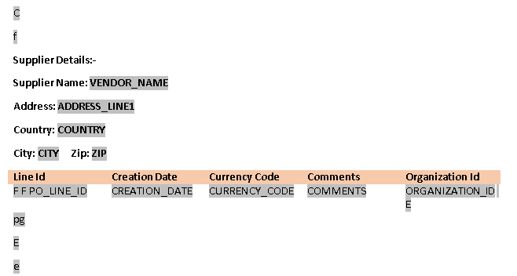

STEP11:SELECT ENTIRE(LIKE ABOVE)->FIELD BROWSER.



STEP12:(IN PLACE OF REF)CHANGE G1 TO CURRENT-GROUP().

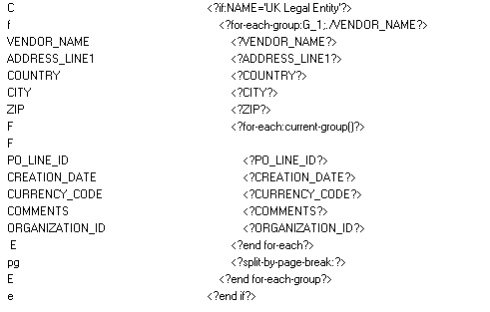

STEP13:FINAL CODE SNAP(REFERENCE).

STEP14:SIMILARLY,REPEATE THE SAME STEPS FOR OTHER TWO BU’S.

STEP15:SAVE REPORT AND GO TO INSTENCE TO UPLOAD LAYOUT.

**RETURN BACK TO ORACLE PAGE**

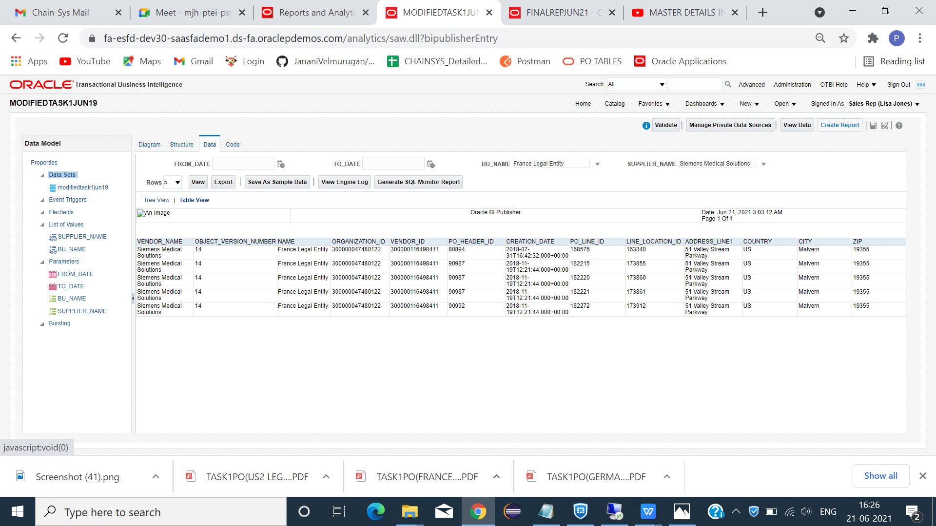

*CLICK -> CREATE REPORT.

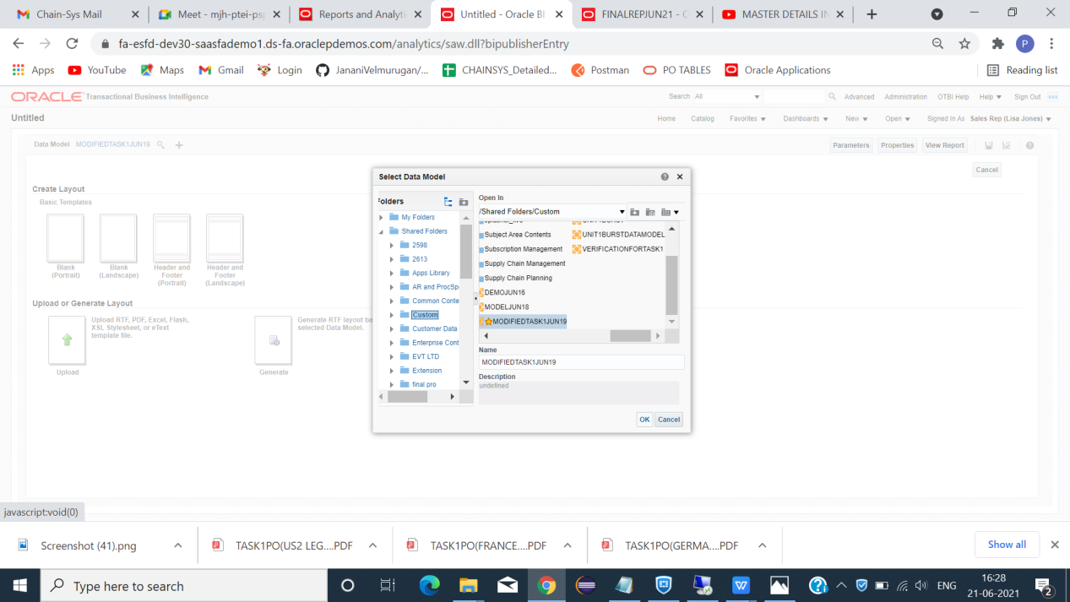

*CLICK -> SEARCH ->DATA MODEL -> (MAP)->OK.

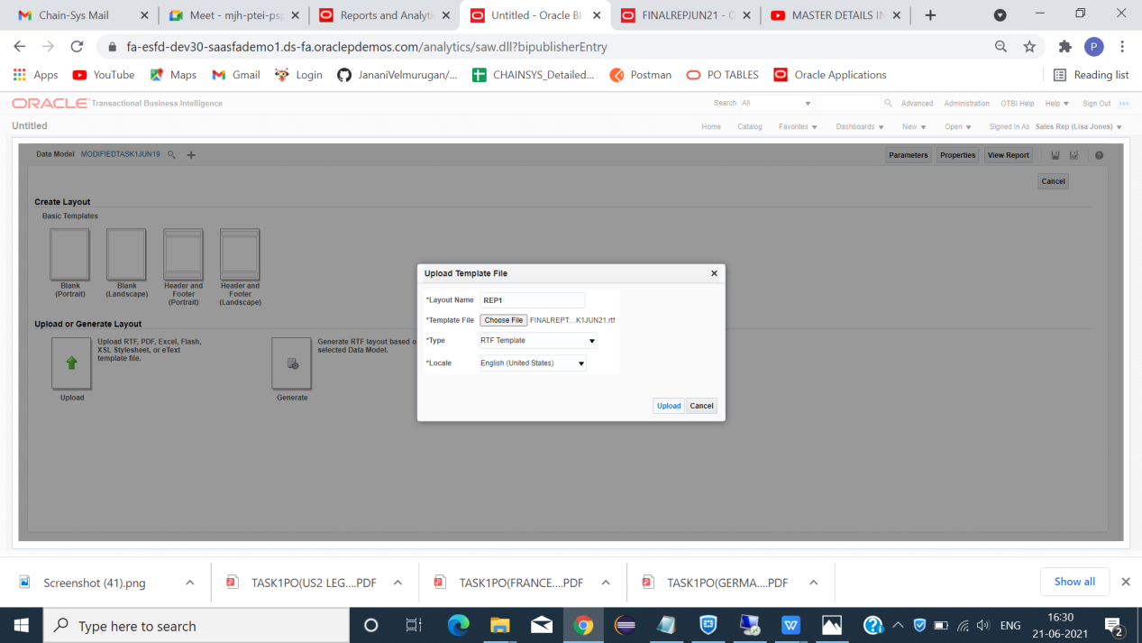

*CLICK -> UPLOAD OR GENERATE LAYOUT -> GIVE LAYOUT NAME -> TEMPLATE FILE(CHOOSE FILE (RTF FILE))->TYPE(RFT TEMPLATE)->LOCALE ->(ENGLISH(UNITES STATE)).

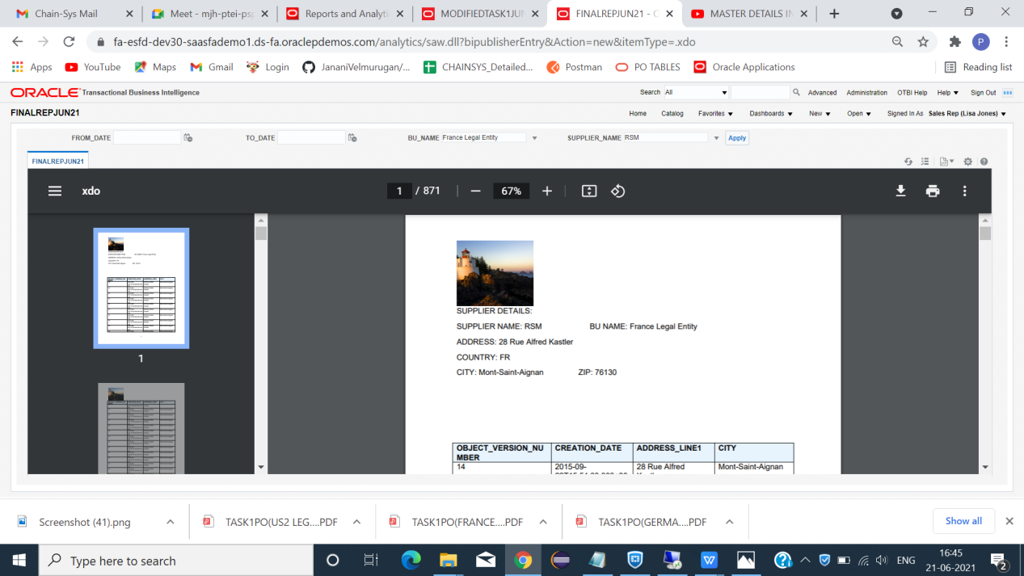

*SAVE -> VIEW REPORT -> DOWNLOAD(TO SAVE YOUR REPORT IN YOUR PREFERRED FORMAT).

==================================**END**=========================================